COURSE: DevOps and Cloud (IBM) (24UAMAE201)
Academic Year 2026-2027
SUBMITTED TO: Mr. Karan Gaikwad Sir
SUBMITTED BY Sonawane Janvi (PRN: 2125UDSF1097)

Step 1: Log in and select the region
➢The AWS Management Console after login, with the region set to Asia Pacific (Sydney). All resources for the Library Management Platform are created in this region.
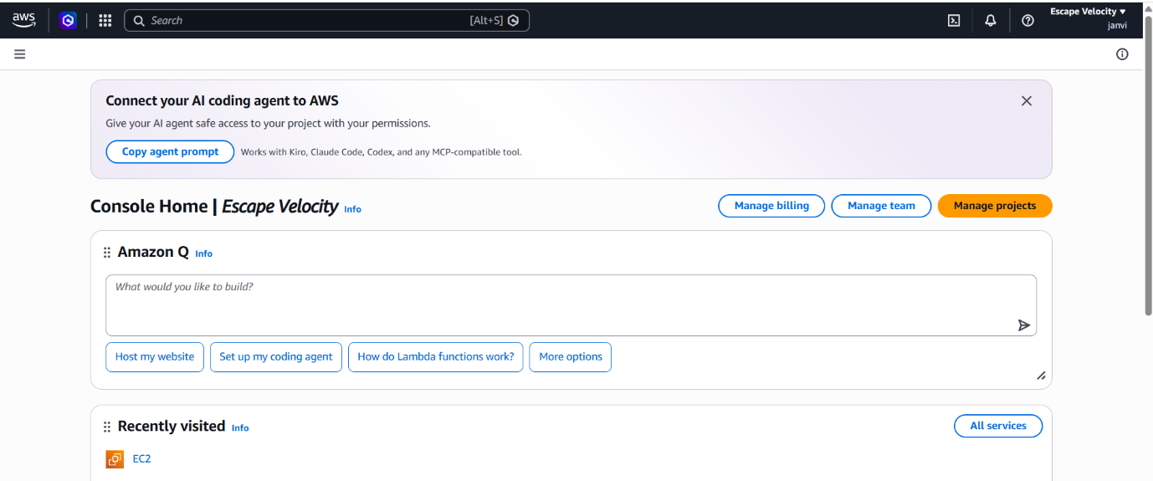
Step 2: Create a key pair
➢A key pair named library-key was created. For Windows servers, the private key is used to decrypt the Administrator password needed for Remote Desktop login
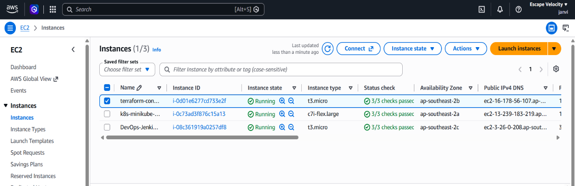

Step 3: Create the security group
➢The inbound rules tab of library-win-sg: Security group works as a virtual firewall. It allows RDP (3389) only from my IP for secure administration and HTTP (80) from anywhere so users can access the library website.

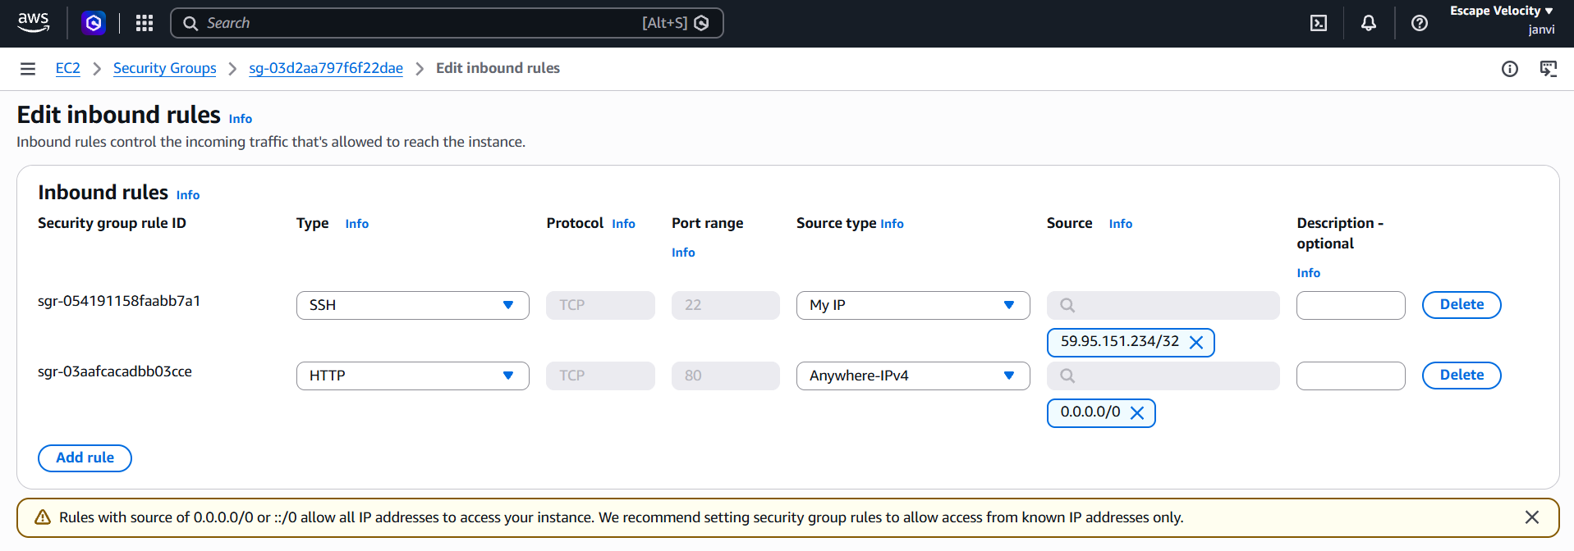
Step 4: Launch the Windows EC2instance
➢A Windows Server 2022 EC2 instance is configured with the key pair and security group created earlier. It hosts the application tier of the platform.
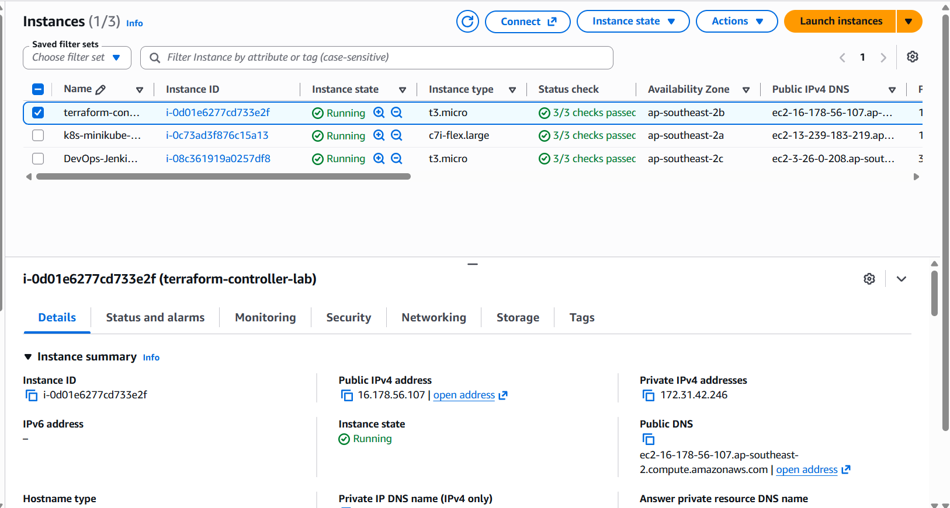

Step 5: Get the password and connect with Remote Desktop
➢The Administrator password was retrieved by decrypting it with the private key. This ensures only the key holder can access the server."
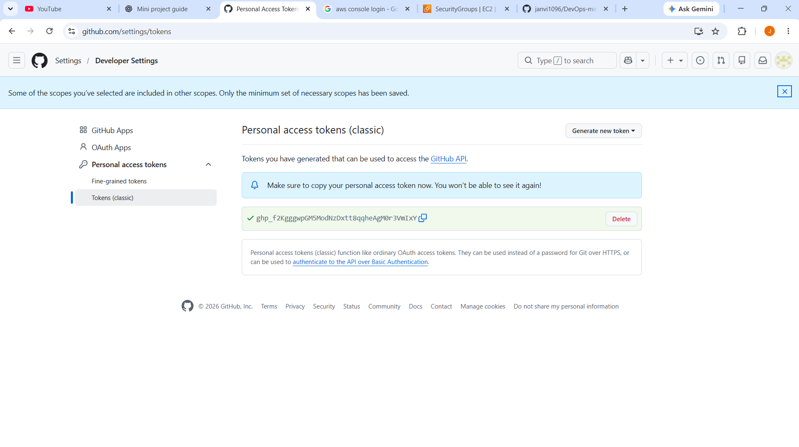
Step 6: screenshot

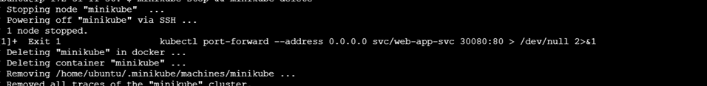
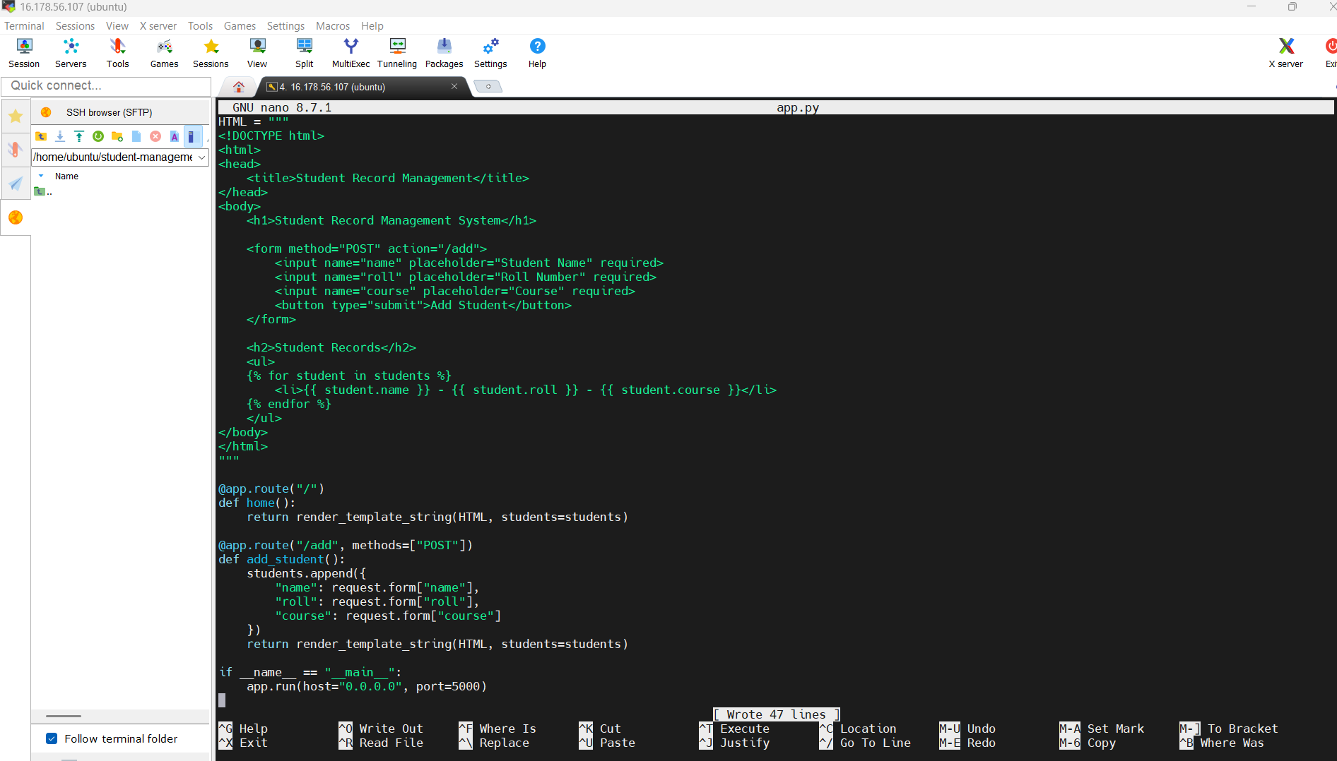

Step 7: create the application

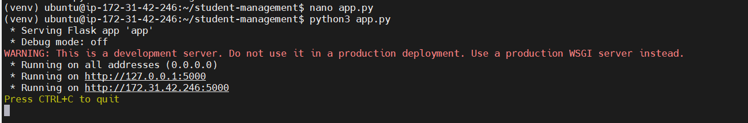

Step 8 Open port 5000 in windows firewall
An inbound rule was created in Windows Defender Firewall to allow TCP traffic on port 5000. This allows incoming requests to reach the application running on the Windows server. The AWS Security Group must also be configured to allow inbound traffic on port 5000. Both firewall settings are required for the application to be accessible through a web browser.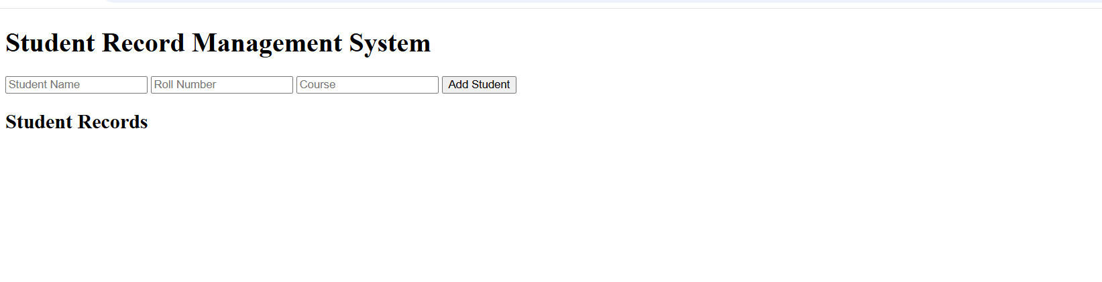
Step 10 : Open the website
